## **WEEK 4 : Introduction to Apache Spark**

**Learning Objectives**

* Use Spark core concepts such as RDDs, transformations, actions to operate on large datasets
* Predict computation performance based on Spark evaluation model
* Explain how Spark achieves fault-tolerance and what are the implications for the end-developer
* Differentiate when to use broadcast and accumulator variables
* Write a Spark application in Python to analyze sample financial data
* Apache Spark is a modern distributed fault tolerant computation platform.

This Unit’s chapter segregation is as below :

### 

### **4.1 Core concepts and abstractions**

#### **4.1.1 Welcome**

Historical Background

* The project started in 2009 in AMP lab in UC-Berkeley. Initially, Spark was a research project with a focus to build a fast in-memory computing framework.
* Three years later in 2012 Spark had the first public release. As Sparks started to gain traction in the industry, it was no longer a research project, and to facilitate better development model and community engagement Spark has moved to Apache Foundation.
* Becoming a top level project in 2014. In the same year Spark has reached version 1.0
* Two years later in 2016, 2.0.

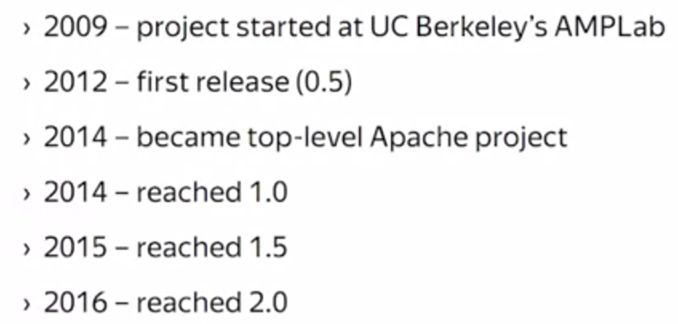

Spark development can be thought of in epoch terms, where every epoch has its own key ideas to explore and its own goals to achieve.

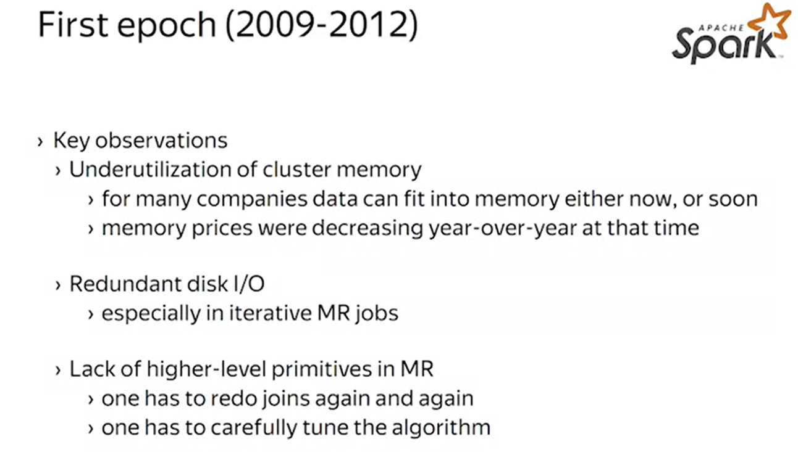

The first epoch is the inception of Spark. Original development was motivated by several key observations.For many use cases, it was questionable if the MapReduce is an efficient model for computations.

* First, it was observed that cluster memory is usually underutilized. Some data sets are small enough to fit completely in cluster memory, while others are within a small factor of cluster memory. Given that memory prices are decreasing, year over year it is economically efficient to buy extra memory to feed the entire data.
* Second, there are redundant input and output operations in the MapReduce. For ad-hoc tasks, it is more important to reduce the completion time, rather than provide durability of the storage, because ad hoc queries generate many temporary, or one off data sets that could be quickly disposed.
* Third, the framework is not that composable, as developers would like it to be. For example it is tedious to reimplement joints over and over again, as a code reuse is complicated requiring some engineering discipline.

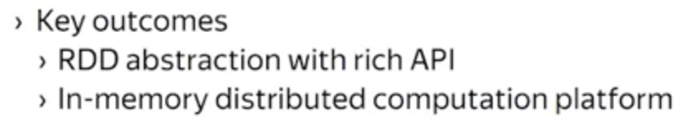

Spark addresses these issues. Many design shortcomings were fixed by introducing an appropriate composable abstraction called RDD. Also RDD abstraction allowed for more flexibility for the implementation and the execution layer thus, addressing the performance issues.

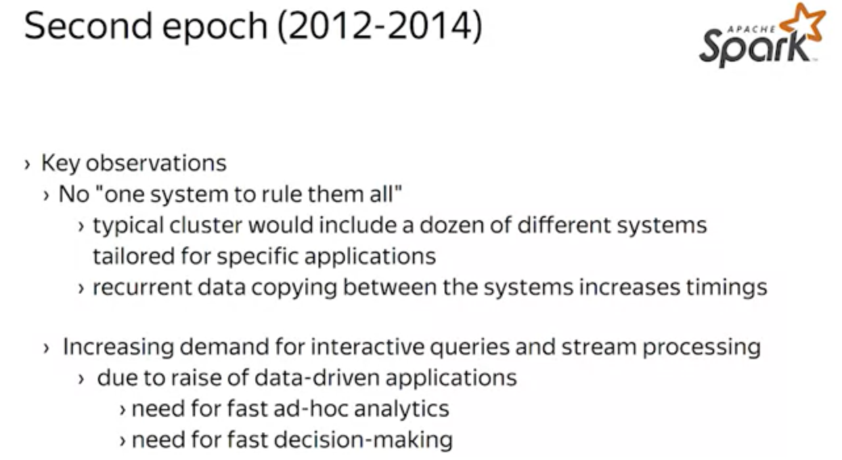

The second development epoch, was about the integration. The key observation, was that

* Typically users had several frameworks installed on their clusters, and each of these frameworks was used for its own purposes . An example here is the MapReduce use for batch processing, Storm for stream processing and Elastic search for interactive exploration.

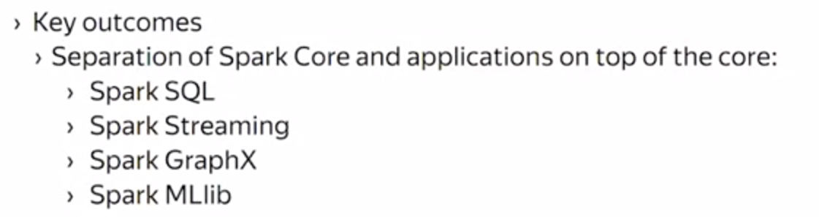

Spark developers, try to build a unified computation framework suitable for both batch processing, stream processing, graphical computations and large scale machine learning. The effort resulted in the separation of Spark core layer consisting of basic abstractions and functions, and a set of Spark applications on top of the core.

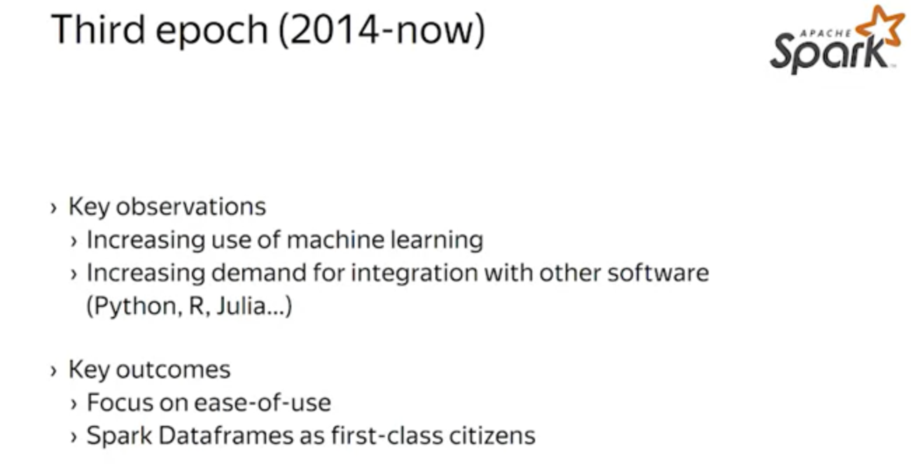

The third development epoch, which is still ongoing is driven by the wide adoption of Spark in data science community.

* Many data scientists, use specialized libraries and languages like R or Julia in their everyday work. These tools, adopt the relational data model. Spark has embraced the same model in the form of Spark data frames, thus, enabling smooth and efficient integration with the data scientists tools.

#### **4.1.2 RDDs**

Here we will discuss about the RDD abstraction in Spark. This is a core abstraction enabling both an efficient execution for a computation, and a flexible and convenient formalism to define computations.

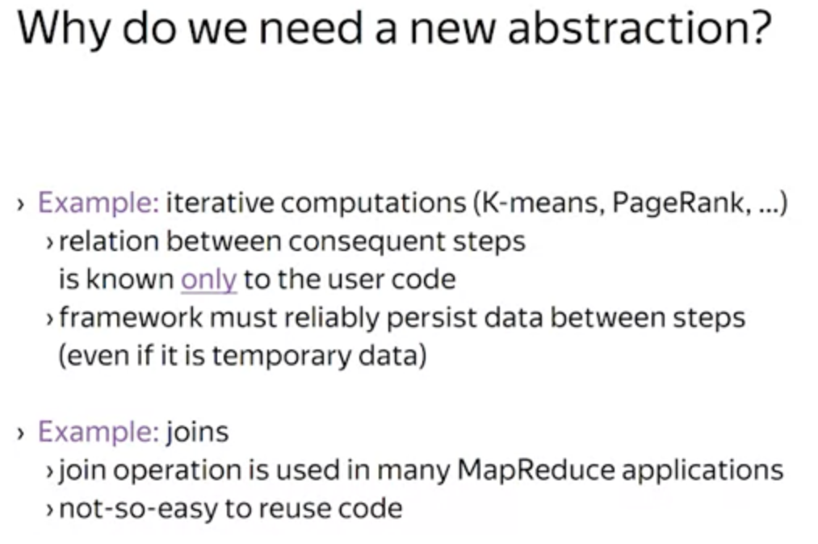

Consider the case of iterative computations in the MapReduce. For example, K-means or PageRank. Iterative computations are composed of the consequent MapReduce jobs where the output of a previous job serves as the input for the next job. There are two issues with these computations in the MapReduce framework.

* First, the relation between consequent jobs is known only to the user code, but not the framework. Therefore, the framework has no capabilities to optimize the whole computation, for example, by tuning the number of registers.
* Second, which is actually particular but important case of the first issue, the framework must reliably persist intermediate data, thus generating excessive IO. For example, if a K-means computation executes five minute long jobs, the whole computation takes just five minutes. It is unlikely for a machine to fail within a five minute interval, but the framework, again, has no capabilities to exploit this observation. In the same scenario, Spark is trying to keep the data in the memory, effectively eliminates an intermediate disk persistence, and thus improving the completion time.
* Thired, is the case of joins and other high level operations.In MapReduce application, it takes some engineering effort to reuse the code between two different applications.

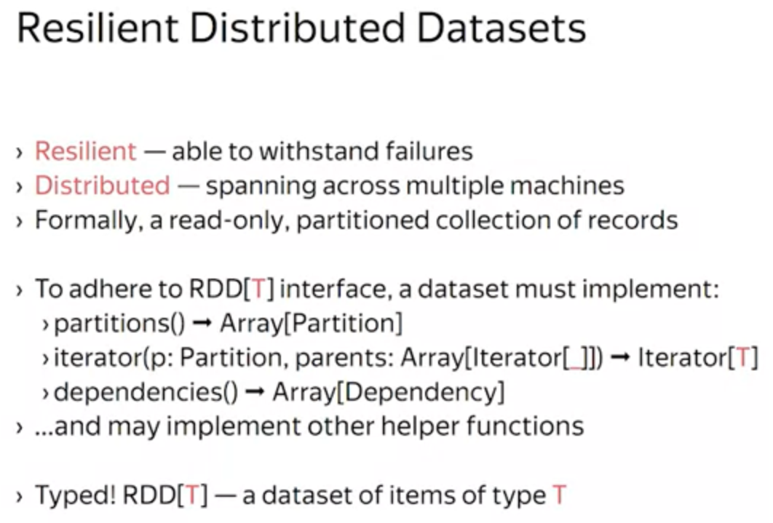

RDDs stands for Resilient Distributed Dataset. The name captures two important properties we are looking for.

* Resilient means that we must be able to withstand failures and complete an ongoing computation.
* Distributed means that we must account for multiple machines having a subset of data.

Formally, RDD is a read-only, partitioned collection of records. To say that the dataset is an RDD, the dataset must adhere to the RDD interface:

* The dataset must be able to enumerate its partitions by implementing the partition's function.
* The partition is an opaque object for the framework. It is passed back to the iterator function of the RDD, when the framework needs to read the data from the partition.
* There is a dependency tracking in RDD. Interface wise, it is enough to say that the dataset must be able to enumerate its dependencies and provide an array of dependency objects. The dependency object maps partitions of the dataset to the dependencies that are partitions of the parent dataset. Those parent partitions are injected into the iterator call when creating a reader.

The dataset must be typed. This allows type checking to catch errors early on, before the actual execution.For example, an RDD[strings], or an RDD[integers]. The dataset may implement other helper functions like the get location function, which hints at the machine that has the given partition.

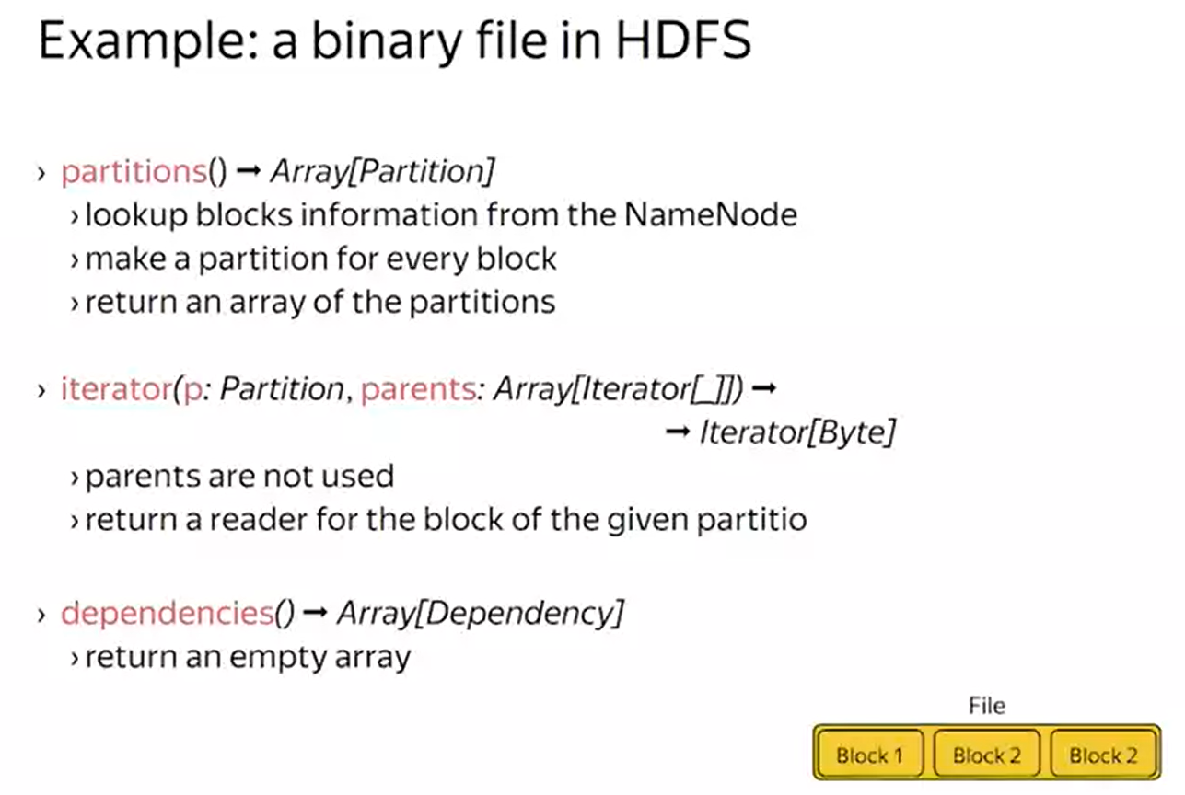

Let's take a look at the example. Consider a binary file stored in HDFS. Let's see how you can implement the necessary functions to make the file in RDD.

* First, how can you partition the file? As you have learned in the first week, HDFS splits every file into blocks. These blocks are perfect candidates to be the partitions of the file, precisely, to implement the partition's function, you need to lookup the blocks for NameNode, create a partition for every block, and return the partitions.
* File reading does not depend on any other RDD, nor on any other partition. So implementing the dependencies function is trivial. It returns an empty array.
* As for the iterator function, you need to extract the block information from the partition, and use it to create a reader from HDFS.

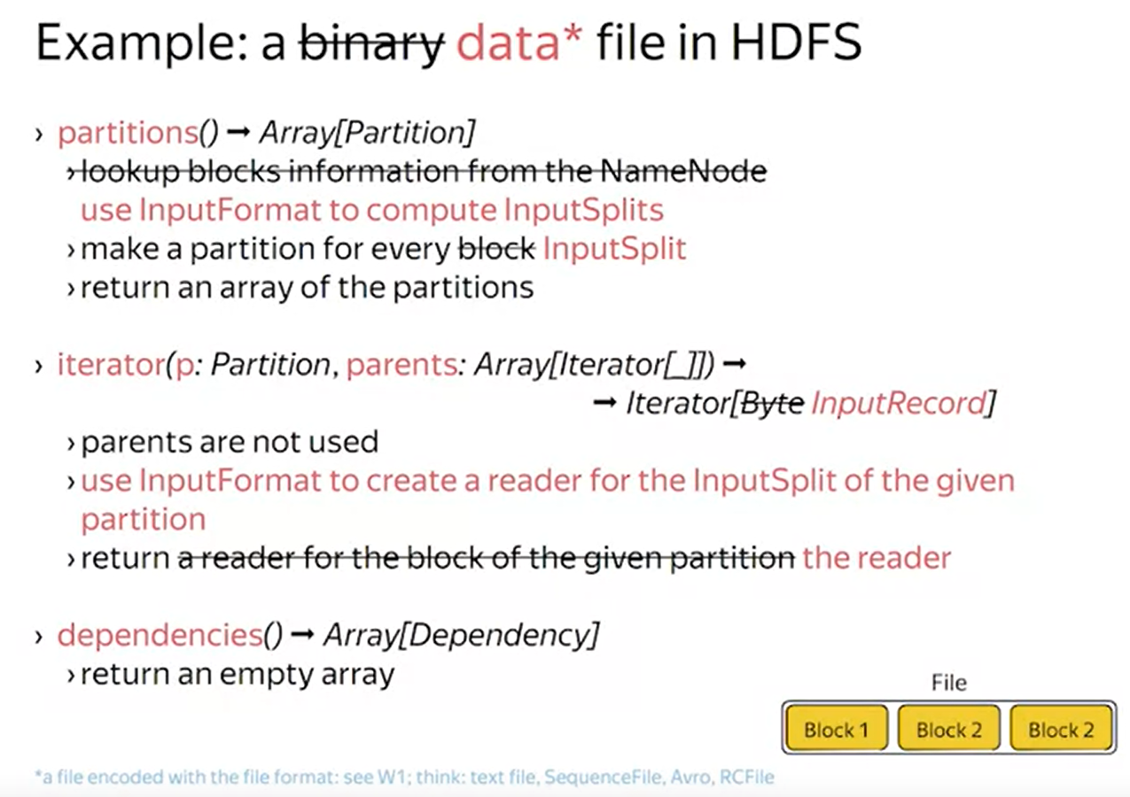

Now, let's make this example a bit more complicated. Usually, you are interested in reading records from the file rather than a raw bytes. As you know from the first week, in Hadoop, there are plenty of formats available to encode and decode data. Technically, every file format comes with the implementation of the input format interface which allows you to split the file. Every split is encoded with the object with the input split interface, and you can pass this object back to the input format object to get an iterator over the records in the given split.So, you can change the implementation of the RDD functions to make use of the file formats. The sketched implementations is actually pretty close to the real one used in Spark to access files in HDFS.

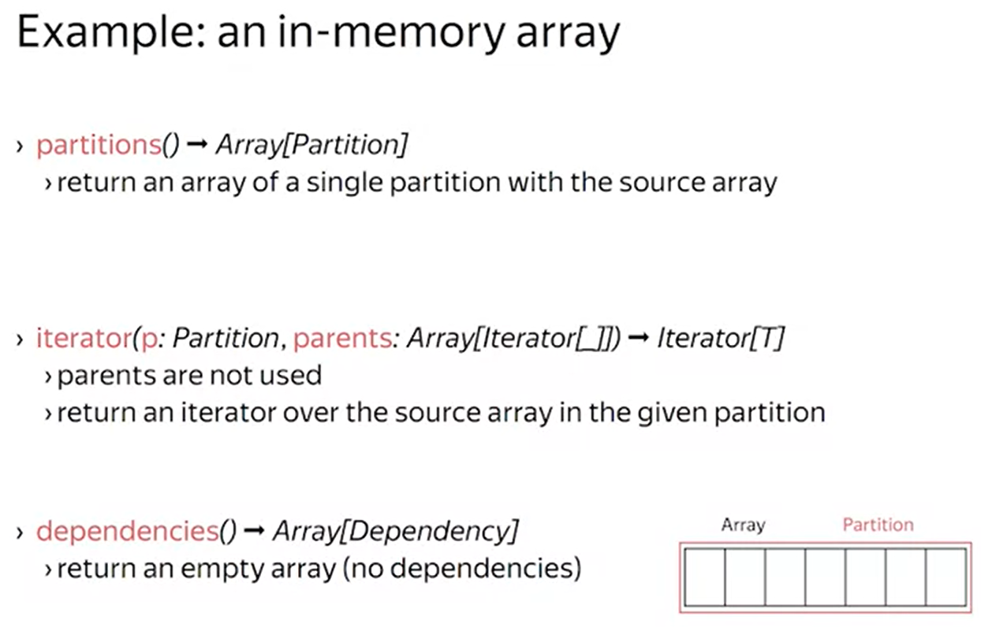

Another example, an in-memory array. The simplest way to make the array in RDD is to pretend that there is a single partition with the whole array. In this case, the partition object keeps a reference to the array, and the iterator function uses this reference to create an iterator.

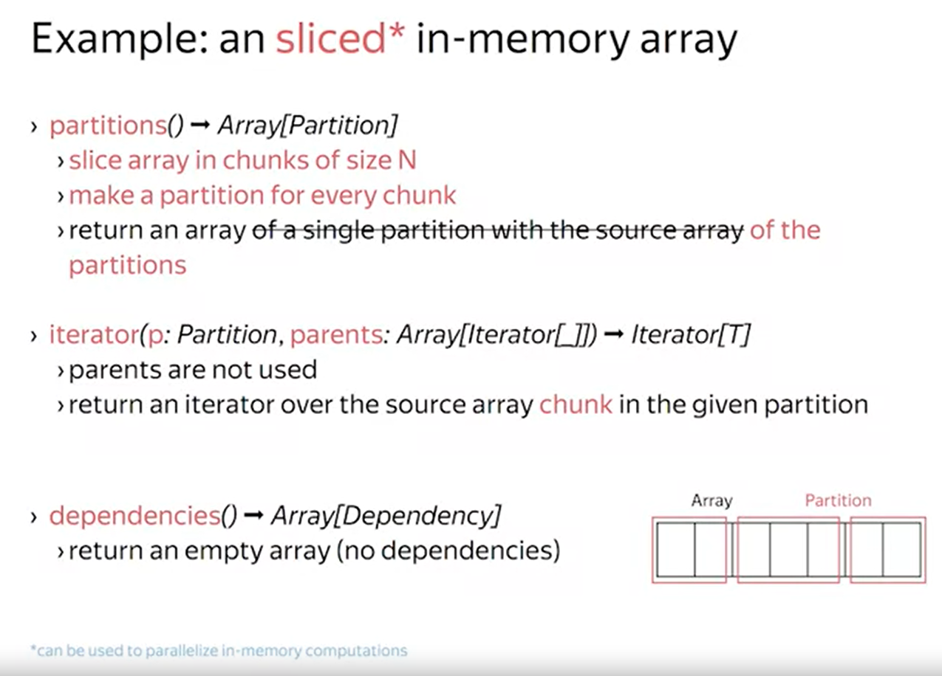

We can make this example a bit more interesting if we slice the array into chunks. The partition, in this case, corresponds to the chunk of the source array. The reason why you may want to slice the array is to gain parallelism. As you will see later, partitions are handled in parallel.

##### **Quiz**

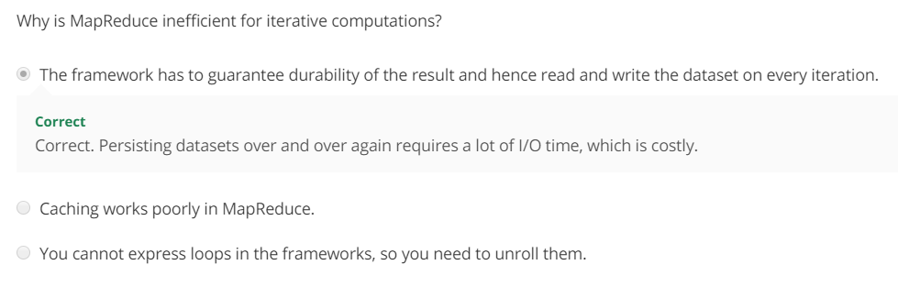

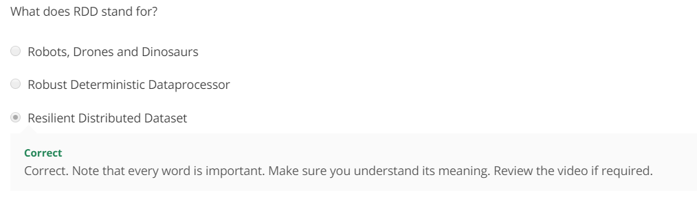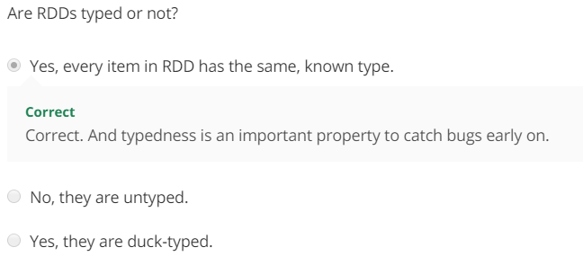

##### Summary

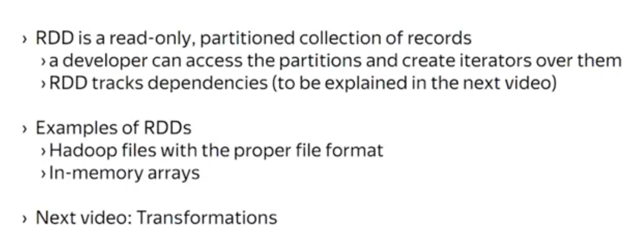

* RDD is a read-only, partitioned collection of records. The collection or the dataset must provide information about its partitions, and provide means to create an iterator over the partition. These functions are a part of the RDD interface.
* There is also a dependency tracking built into the RDD interface, and you will learn its purpose in the next video.
* There are two important examples of RDDs. They are Hadoop files and in-memory arrays. These two kinds of RDDs are used extensively in the production code.

#### **4.1.3 Transformations 1**

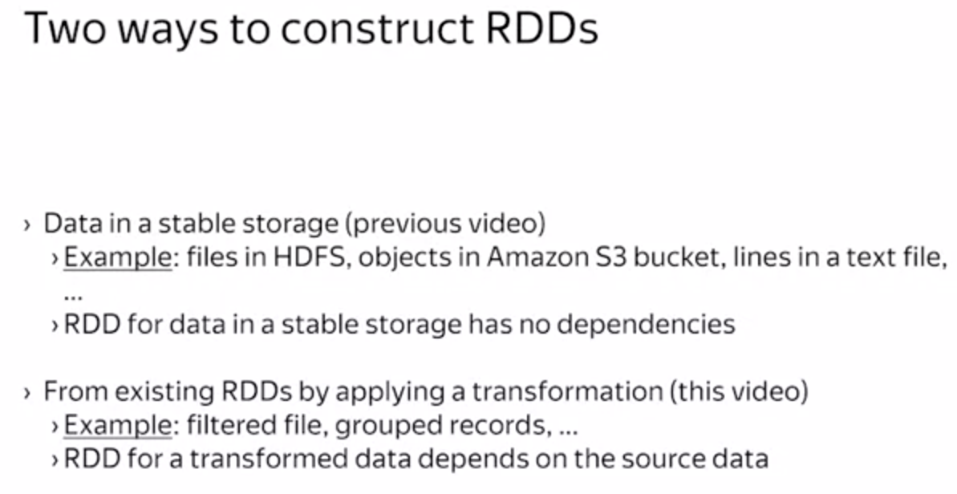

* First way to create an RDD is using data stored in a stable storage.
* Since RDD is said to be a read-only collection of records , there is a second way how you can create an RDD from the existing one. For example, with transformations, you can filter records and group them by a key.

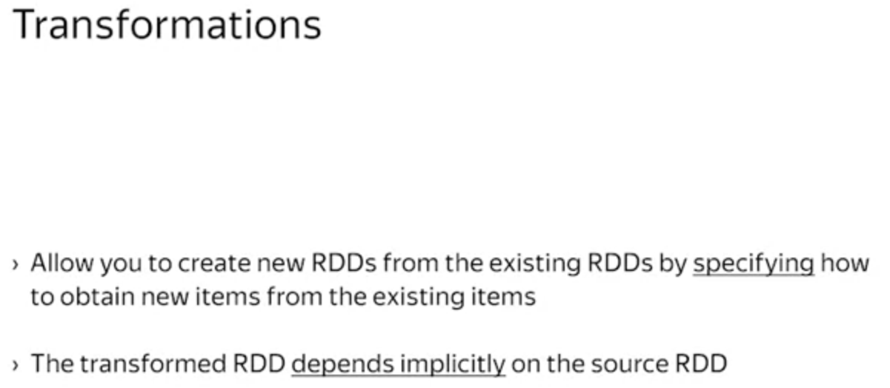

More precisely, transformations allow you to create new RDDs from the existing RDDs by specifying how to obtain new items from the existing items. That implies that the transformed RDD depends on the source RDD to be useful. To make this definition more accurate, let's take a look at the examples.

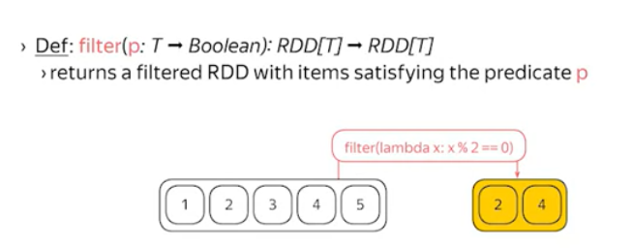

A simplest transformation is the filter transformation. It is parameterized by a predicate. The result in DataSet only contains items that satisfy the predicate. As you can see here in the example, if you take the RDD with numbers for one to five, and apply the filtered transformation that keeps only even numbers, you will get the RDD that effectively contains numbers two and four.

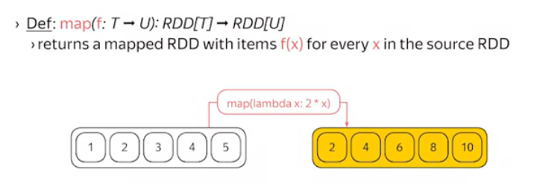

Another transformation is the Map Transformation. It is parameterized by a math function that transforms or maps a single source item into a single transformed item. For example, the map transformation with a function that doubles the input number, converts the RDD with numbers from one to five to the RDD with numbers two, four, six, eight and ten.

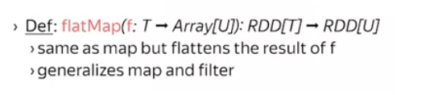

A generalization of filter and map is called flatMap. Here, a function maps a single source item into a possibly empty array of transformed items. For example, to filter out the item, you simply need to map it into the empty array. The map function would be implemented as mapping to the singleton array.

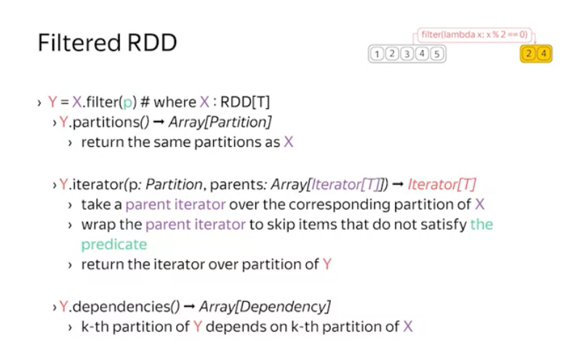

Let's take a look at how you can implement the filtered RDD. Recall, you need to implement three functions: partitions, iterator and dependencies. Since the transformed RDD's mostly the same as source one, you can reuse partitions of the source RDD as there is no need to change the partitioning. Now, every field or partition depends on the source partition. You can establish this relation by providing a dependency object that establishes one-to-one correspondence between the filtered and the source partitions. Now, as you provided dependencies for every partition, when creating an iterator over the filter partition, Spark would inject an iterator of the source partition into the iterator function call. So, your job now is to build an iterator over the filter partition. This could be done by reusing the parent iterator. When requested for the next value, you can pull values from the parent iterator until it returns you an item that satisfies the predicate. And I think here is that you do not need to know about implementation details or the parent RDD at all.

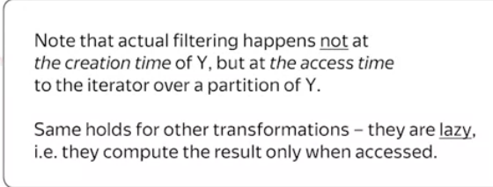

If you noticed, you have implemented this so-called lazy iterator. That means that when you create a filtered RDD, no immediate filtering occurs. The filtering starts to happen only when you start to pull items from the iterator. This is a property of laziness.  
All the transformations in Spark are lazy. They merely create a description of what needs to be done and then wait until you start requesting the data, and that makes sense. If you are working with a cluster and you have just made a filter RDD, it is unclear where to start executing the operation and where to deliver the result. Obviously, you do not want all the data to go through your computer. And as you will learn later, there are other operations available in Spark called "Actions" that trigger the actual computation, and hence, involve the postponed transformations.

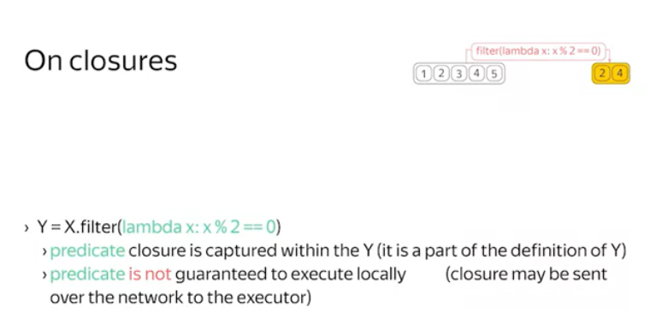

One important technical detail, as the filtering is done lazily, the predicate closure must be captured within the RDD. That means that you have to be careful about the code you put in the predicate. You have no control on when and where this code will be executed. That means it is a bad idea to, say, access the local files or to capture the local references in the closure.

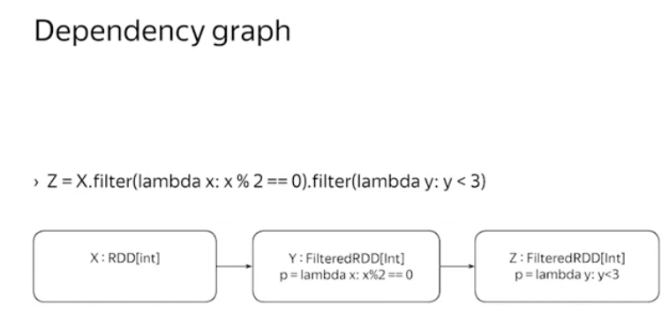

Whenever you apply a transformation to the RDD, you implicitly construct a dependency graph on the RDDs.This graph is used by the framework to schedule jobs as we will see later.

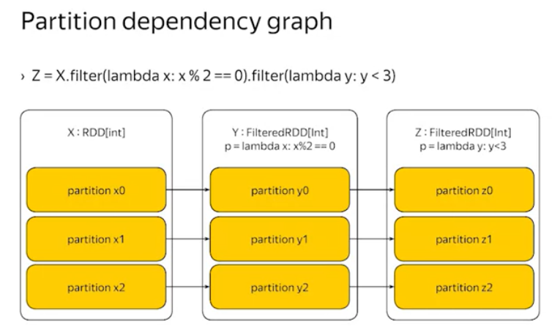

Moreover, you can imagine a partition level dependency graph where vertices correspond to partitions and edges to inter-partition dependencies. In the case of filtered transformation, this is a slice graph with a few edges.

##### **Quiz**

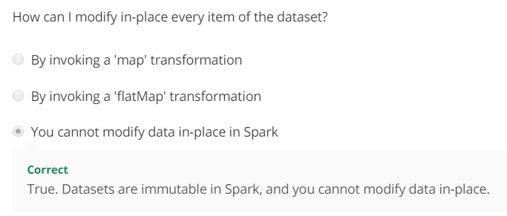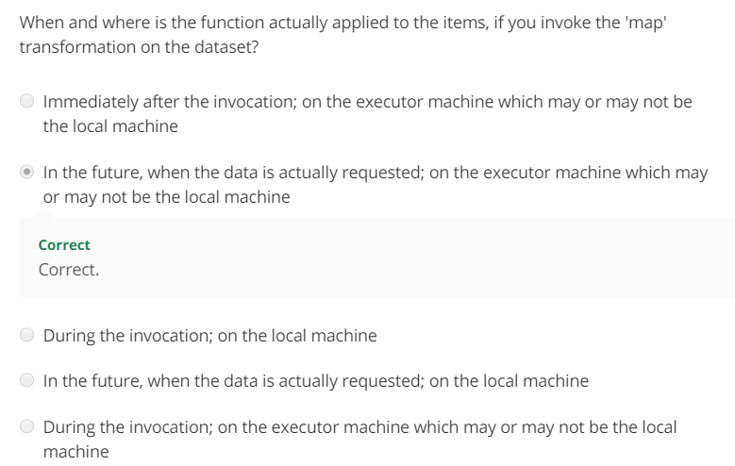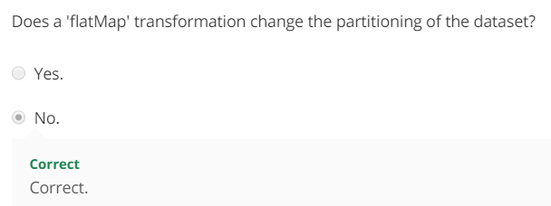

#### **4.1.4 Transformations 2**

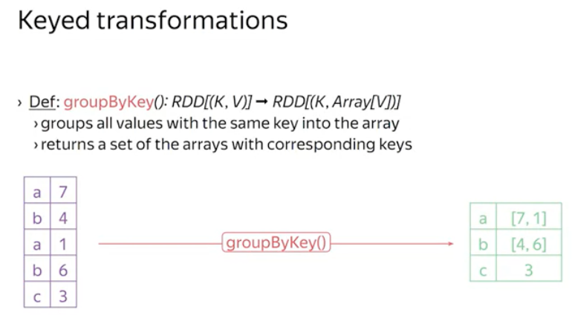

We will see keys transformation for keyed RDDs. The very basic transformation for a data set of key value pairs is the groupBykey() transformation that groups all the values with the same key into the array.

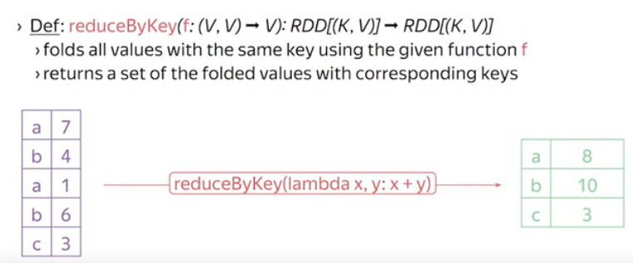

And there is a reduceByKey() transformation that folds all the values in the same key using the provided reduce function.

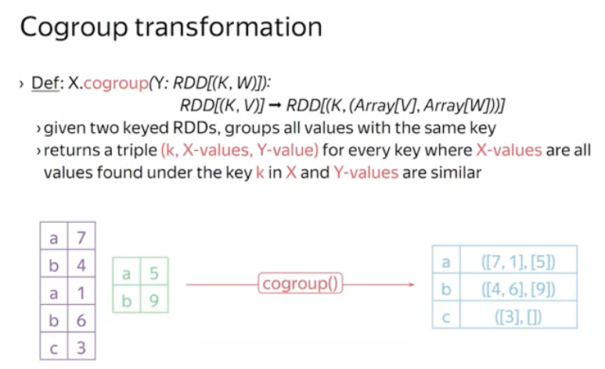

Cogroup operates on two keyed inputs. The result is the keyed output with the value being a pair of arrays holding the values collected for the given key from the first and the second input. Take a look at the example. The cogroup transformation allows you to compute any kind of a join between two data sets.

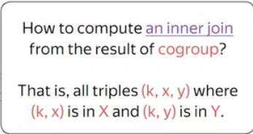

How to perform an inner join or two data sets. The correct answer is to apply the flat map transformation on top of the result of the cogroup transformation. The map function has to compute the Cartesian product between the two arrays.

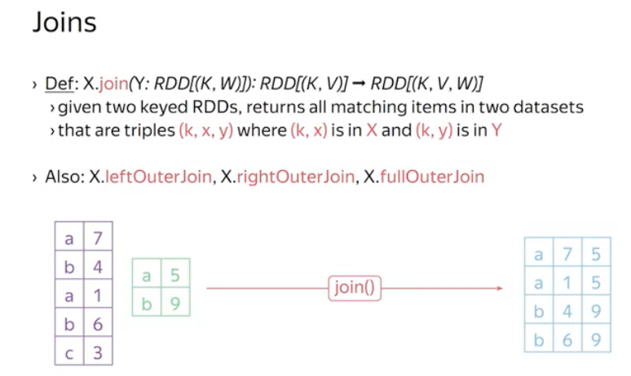

The join transformation produces the inner join of two data sets. Besides that, there is the full outer join transformation. The difference between the inner join and the full outer join is how to treat single-sided keys. For the inner join, if the key is present only in the one side of the join that is in one data set. Then it is omitted from the result. For the outer join, one-sided keys are added to the result with appropriate null values.

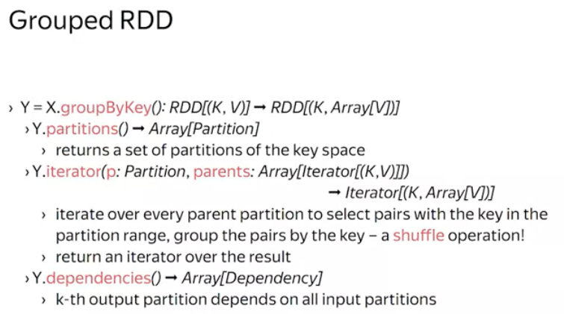

Now let's sketch the implementation of the groupby transform. First, recall you need to somehow partition the key space. This could be done, for example, by using the hash partition then to compute the values in the resulting partition, you need to scan over the entire source RDD to select only the pairs that belong to the output partition. This behavior is different from what you have seen in the flat map like transformations. Here, a single output partition depends on all the input partitions. This is inevitable as you have to redistribute all the values between all the partitions. This separation is called a shuffle.

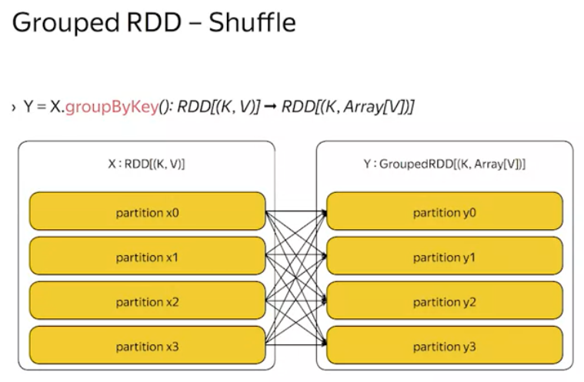

In fact, if you imagine the partition dependency graph you will find it rather similar to the MapReduce shuffle. The actual shuffle implementation exhibits the same performance issues as in the MapReduce Spark. It is in [inaudible] in network [inaudible] and in memory consumption depending on the data distribution.

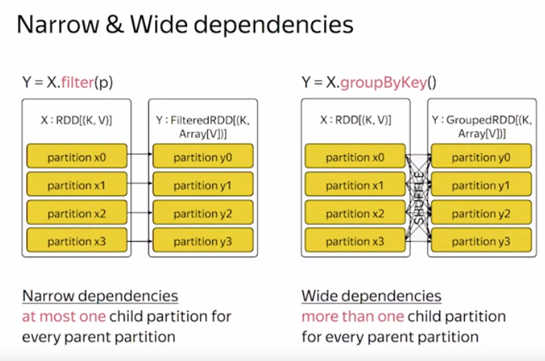

Since the shuffle occurs in other transformations as well, the shuffle implementation is shared among different data sets. Also, presence of the shuffle phase affects scheduling of the computation and its resiliency. Therefore, Spark differentiates between narrow dependencies and wide dependencies. Narrow are those with at most one child partition for every parent partition. Wide dependencies have more than one child partition for every parent partition.

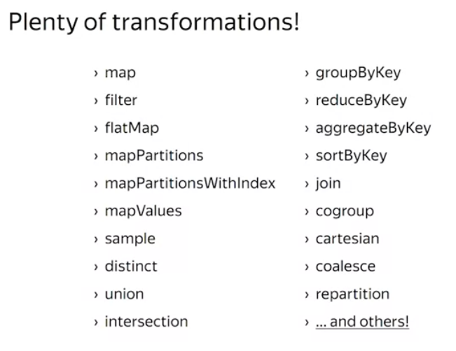

Concluding, there are a plenty of transformations available in Spark. Some of them are purely of technical purposes. For example the coalesce and re-partitioned transformations just change the number of partitions in the RDD. While the others, like distinct or sortbyKey are rather powerful.

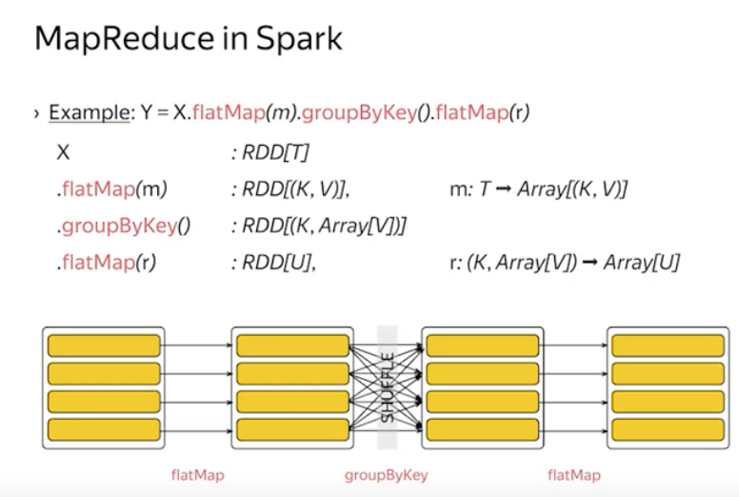

In fact, you can express any MapReduce computation in Spark as the flatmap followed by the groupByKey, followed by one more flat map. The evaluation of the computation would follow pretty much the same scheme as in the MapReduce. Mappers would be spawned close to the input data. The map output would be shuffled and distributed among reducers.

##### **Quiz**

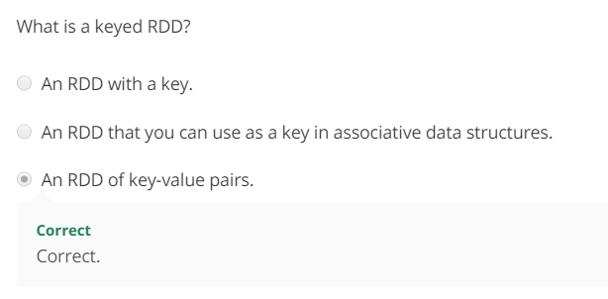

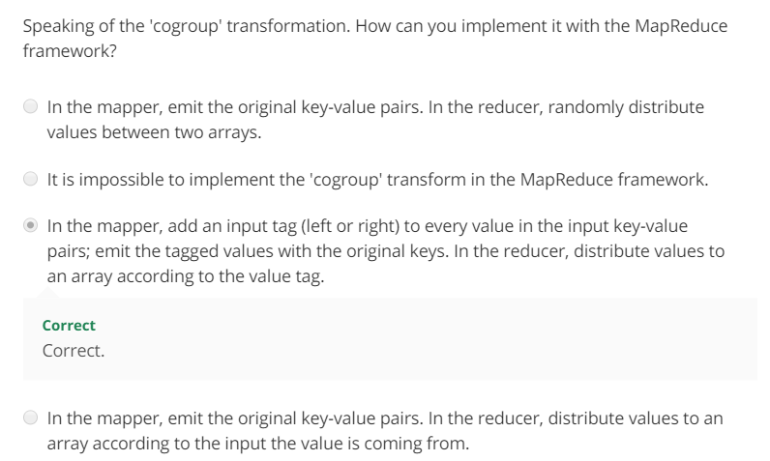

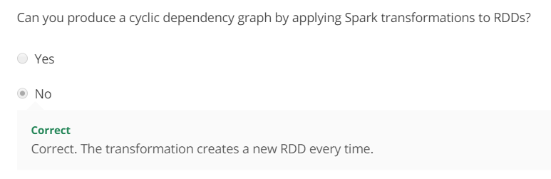

##### **Summary**

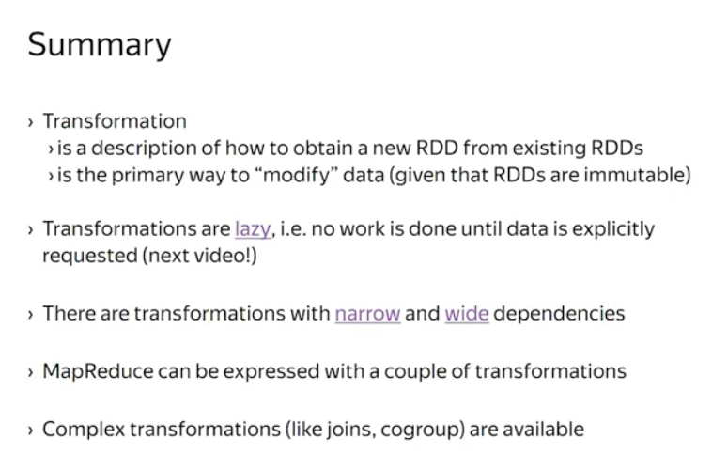

Key points for you to remember:

* There are two ways of creating RDDs in Spark by using data from a stable storage or by applying transformations to the existing RDDs.
* In latter case, you merely create a description of what needs to be done to obtain the result in data set. That means that transformations are lazy. Data materialization has to be explicitly triggered by an action.
* It is important to distinguish transformations with narrow and wide dependencies. Narrow dependencies are, loosely speaking, local. And wide dependencies require data shuffling.
* Any MapReduce computation can be expressed with a couple of Spark transformations.
* And more powerful transformations like Joins and Cogroups are implemented in the framework in the generic way.

#### **4.1.5 Actions**

The actual computations took place when the data was being accessed. In Spark, the operation that triggers the computation is called an action.

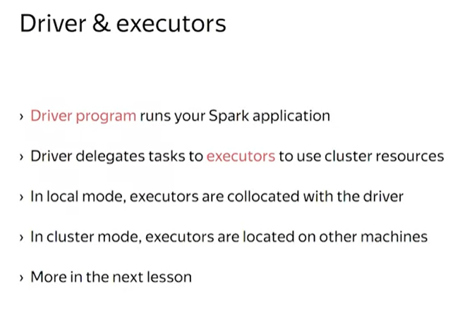

* When you write and invoke your Spark application, it runs within the driver program. That is the program which drives the execution of your Spark application. Sometimes, it's simply called the driver.
* When something must be done with the data, the driver schedules tasks to be executed by executors.
* When running locally, the executors are collocated within the same process as the driver program.
* When running in a cluster mode, the executors are located on the cluster machines, thus allowing you to use the cluster for a computation.

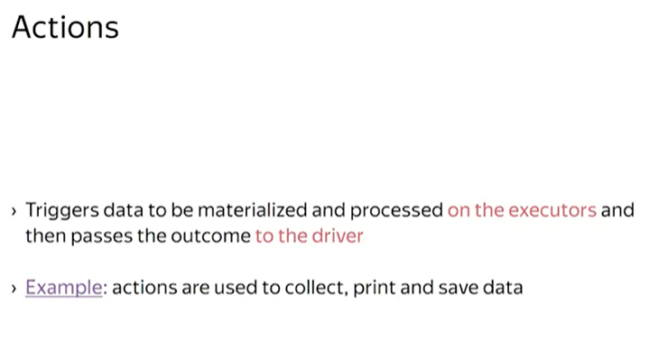An action is the operation on RDD that triggers data to be materialized and processed by the executors, and then passes some results back to the driver.

This is a common source of confusion, so I'm going to reiterate it. Actions, together with a transformation code, are executed elsewhere, not in your driver program. Your driver program receives only the outcome.

Spark does a great job of abstracting away the execution details, and that improves your developer productivity and code readability.

But it requires some carefulness to get everything right.

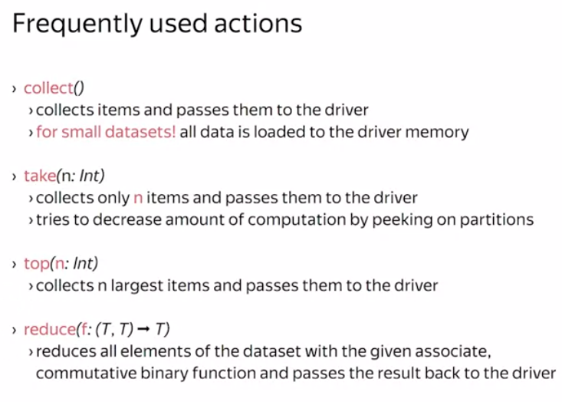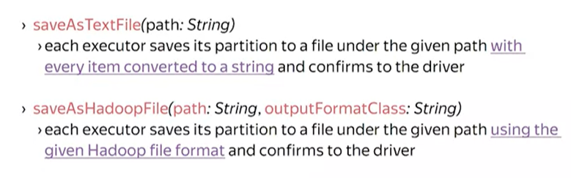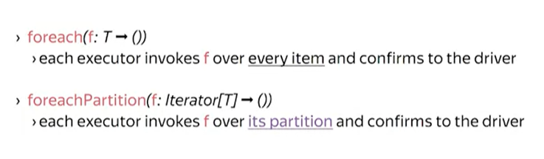

Here are frequently used actions.

* The collect action, well, collects the result into the memory of the driver program.This action is intended to be used when the output is small enough to fit into the driver's memory.
* Otherwise, the take action may help. It takes the given number of items from a data set and passes them back to the driver.The take action tries to use only the first partition of a data set to optimize the completion time.
* While take returns arbitrary elements from the data set, top returns the topmost elements.These actions are useful when exploring the data.
* There is also a reduce action which may be used to compute sums, minimums, maximums over the data.
* When the result is large enough, you may want to save it to HDFS for example. Doing so by collecting items in the driver is a bad idea because you will quickly run out of memory.There are special family of safe actions that do heavy work on the executor side and return a confirmation to the driver. SaveAsText file is used for full debugging or for simple applications. As the name suggests, it transforms items to strings and writes them into a file.
* SaveAsHadoopFile leverages Hadoop file formats to serialize data. This function is the common way to save data to HDFS.
* Lastly, if you need to run your own code over a data set, there are foreach and foreachPartition actions that invoke your function on the executor side.You can use this function to persist your data in your custom database for example, or to send data over the wire to an external service, or anything else.

##### **Quiz**

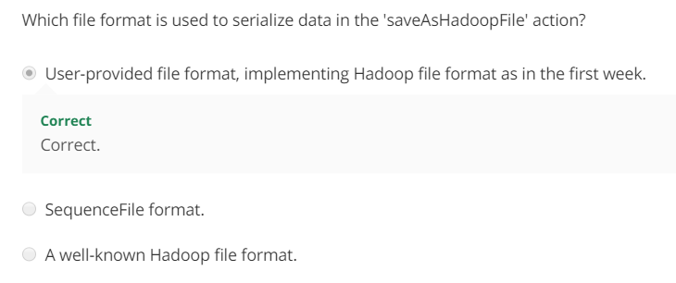

##### **Summary**

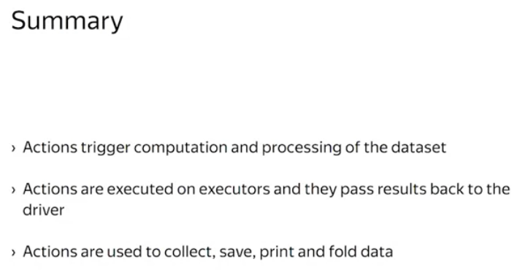

* Actions trigger actual computation of the data.
* In particular, actions are used to collect, print, save, and fold data.
* They are executed by executors and pass a result back to the driver. So please, pay attention to the code you pass to actions.

#### **4.1.6 Resiliency**

You had already learned about RDDs, transformations and actions. Now, it is time to see how Spark achieves resiliency. How it is possible to continue operation despite machine failures in the cluster. There are subtleties in having this property.

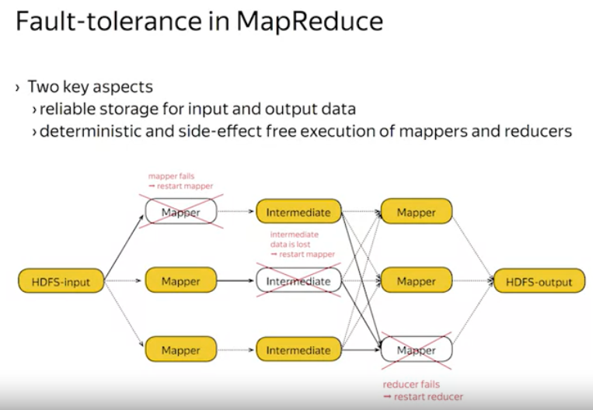First, let's recall how the MapReduce achieves fault tolerance. It does so, by exploiting two properties.

* First, once data is stored in HDFS it is safe.
* Second, if the computation is deterministic, and has no side effects, the framework can restart it multiple times, and get the same result every time.

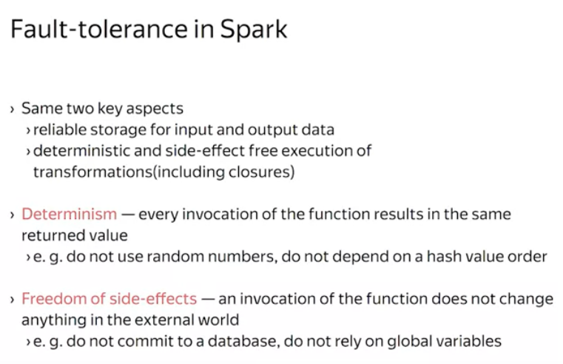

Spark's resiliency is based on the same properties. Spark assumes that every transformation is deterministic, and free of side-effects, to be able to restart any failed computation. In particular, it assumes, the same properties to hold for your closures.

* Determinism properties says that every invocation of the function, results in the same return value.
* Freedom of side effects property says that invocation of the function does not change anything in the external world. For example, writing to a database is considered as a side effect. If your function happens to commit to the database, there is no way to roll back changes in case of failure. Given these assumptions, Spark is allowed to restart the failed parts of the computation.

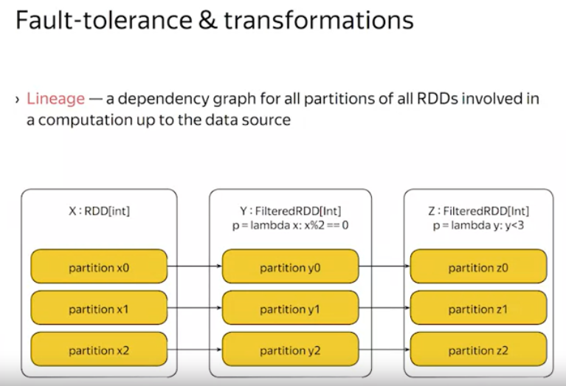

To decide what to restart, Spark keeps track of the lineage. That is a dependency graph for all the partitions of all RDDs involved in the computation. You saw these graphs when learning about transformations. Machine failure renders some partitions in the lineage unavailable.

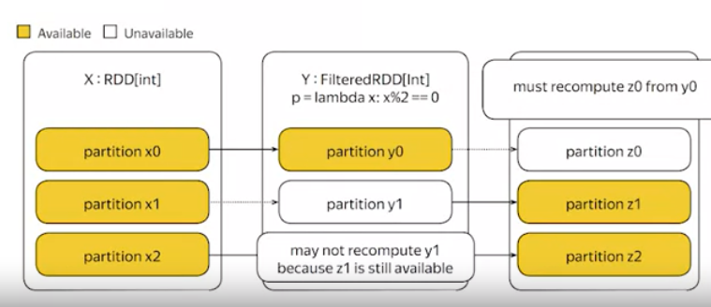

So, to cope with the failure, you must detect which partitions become unavailable, and decide what to restart. Detection is done in the Driver Program, because the Driver Program orchestrates the execution, and already tracks the partitions. Deciding what to restart is easy. Given the failed partition, you look at its dependencies, and if they are alive, restart the computation. If the dependencies are failed as well, you recursively try to recover them. This is a finite process, because the source partitions have no dependencies, and assumed to be stored in a reliable storage.

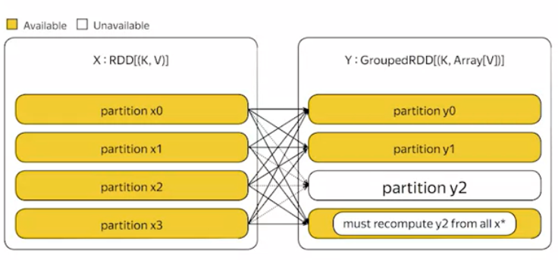

Restarts are slightly more fragile in the case of wide dependencies, because to recompute an output partition, all dependencies must be alive, and there are many of them. So, if dependencies you evicted out of a cache for example, the restart will be expensive.

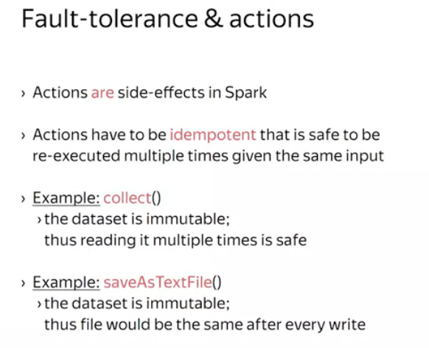

One more important detail is about actions. As you have seen in the previous video, actions are used to communicate with external services like HDFS. This actions do have side effects. Due to restarts, Spark cannot guarantee that an action would be executed exactly once, because its execution may fail in between. Therefore, actions are assumed to be idempotent, that is, safe to be executed multiple times given the same input.

* Consider the collect action. Since all transformations are deterministic, the final data set isn't changed in case of restarts. Therefore, even if the collect action fails, it could be safely re-executed.
* And the same argument is applied to saveAsTextFile action, since the data set is the same, you can safely override the output file.

##### Quiz

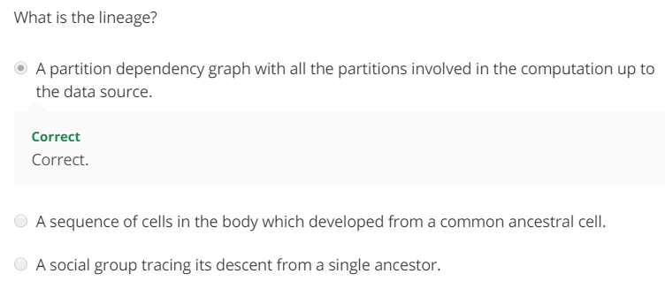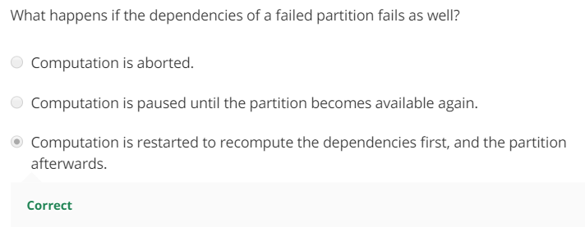

##### **Summary**

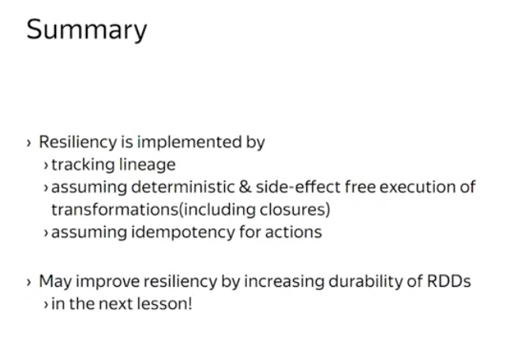

To summarize for you as a developer, it is important to keep in mind that all the closures pass to Spark, must be deterministic and side effect free. Actions require a stronger property, idempotency. These properties cannot be checked or enforced at compile time, and may lead to obscure bugs in your application that are hard to debug and hard to reproduce.

### **4.2 Advanced topics**

#### **4.2.1 Execution and Scheduling**

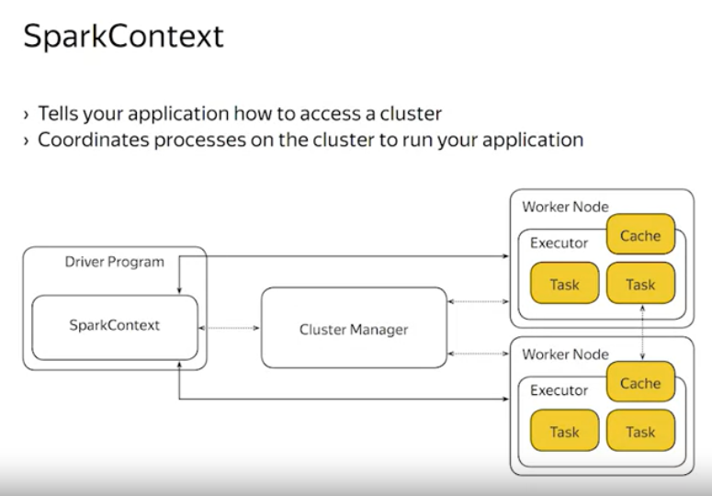

When creating a Spark application, the first thing you do is create a SparkContext object, which tells Sparks how to access a cluster. Sometimes, the SparkContext object is already created for you, as in the Spark shell, for example. Or in a Jupyter Notebook. The context, living in your driver program, coordinates sets of processes on the cluster to run your application.

On a higher level, the workflow is the following. The SparkContext object communicates the cluster manager to allocate executors.

The cluster manager is an external service for acquiring resources on a cluster. For example, YARN, Mesos or a standalone Spark cluster.

So once the context has allocated the executors, it communicates directly with them and schedules tasks to be done.

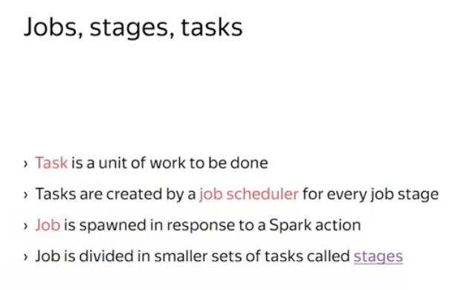

Let me introduce some new terms. Task is a unit of work as we have already discussed. Tasks are created during the scheduling of a job. And every task belongs to the job stage. The job is spawned in response to a Spark action.

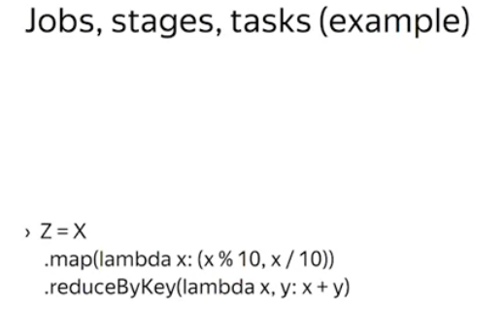

So let's go through the terms once again, but in reverse order.

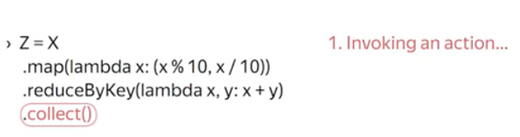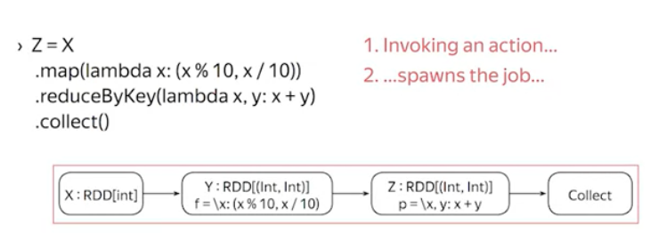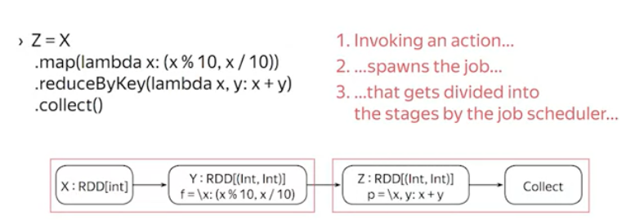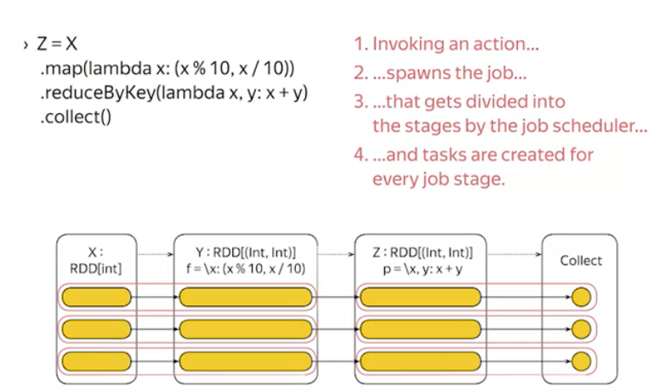

Whenever you invoke an action, the job gets spawned in the driver program. Then the driver runs a job scheduler to divide the job into smaller stages.

Then tasks are created for every job stage.

Finally, tasks are delegated to the executors, which perform the actual work.

All this machinery exists within the SparkContext object. It keeps track of the executors, it spawns jobs, and it runs the scheduler.

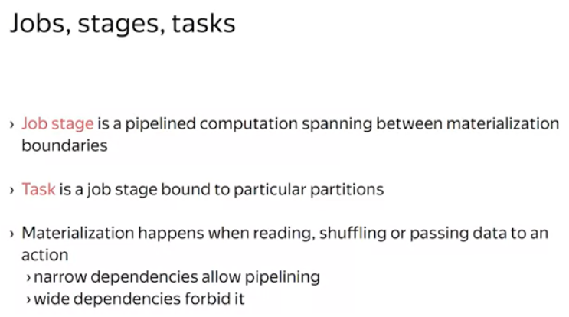

You may wonder what the difference between job stages and tasks is.

Two things, job stages are defined on RDD level. That is, they are not immediately executable.Tasks, on the other hand, are bound to a particular partitions and thus are immediately executable.

The idea behind the job stages is to pipeline computation as much as possible, avoiding unnecessary data materializations. For example, if you applied two filter transformations in a row, it is not necessary to serialize and deserialize data in between. You can simply pass the data through the next predicate.

Data materialization occurs in a few places. When reading, shuffling, or passing data to an action. This is where the distinction between narrow and wide dependencies comes up. Narrow dependencies allow pipelining, a state of flow is straightforward. While wide dependencies forbid pipelining by requiring a shuffle.

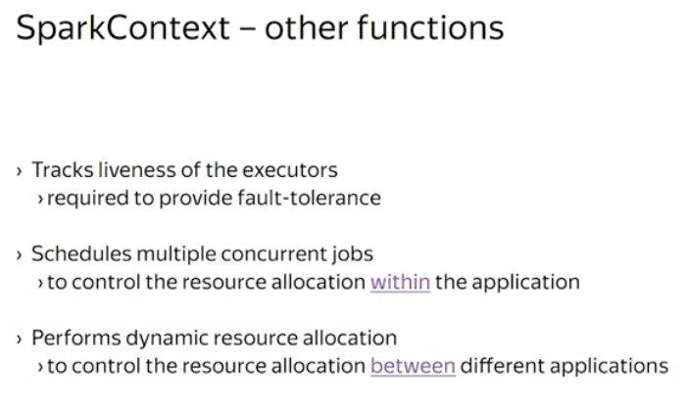

* Lastly, there are a few more technical functions performed by the SparkContext object. First, the context keeps track of live executors by sending heartbeat messages periodically.This is required to detect failed executors around them as you have learned in the resiliency lesson.
* Second, in more complex applications, the context performs scheduling between multiple concurrent jobs within the application.
* Third, the context may perform dynamic resource allocation if the cluster manager permits. This increases cluster utilization in shared environments by proper scheduling of multiple applications according to their resource demands.

##### **Summary**

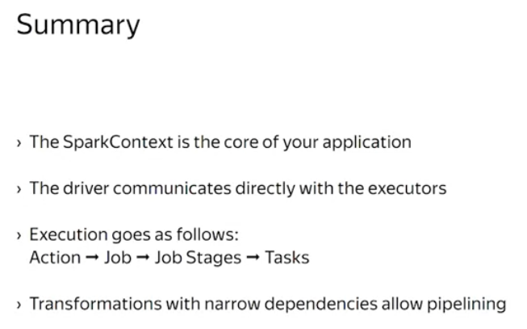

The SparkContext is the core of your application. It allows your application to connect to a cluster and allocate resources and executors. Then whenever you invoke an action, the SparkContext spawns a job and runs the job scheduler to divide it into stages.

That is pipeline-able parts of your computations. And only transformations with narrow dependencies are pipelined.

Then tasks are created for every job stage and scheduled to the executors.

The driver communicates directly with the executors, exchanging with task information and liveness status.

#### **4.2.2 Caching and Persistence**

You will learn how Spark manages it's intermediate data and how can you hint Spark about your access patterns for better resiliency and performance.

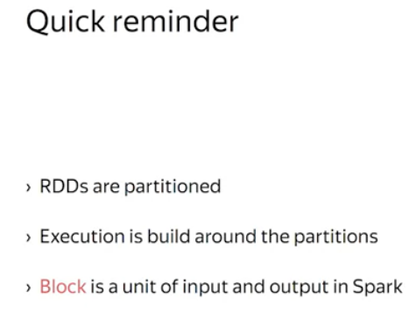

Recall that RDDs are partitioned and the whole execution layer builds around the partitions. Each task processes a small number of partitions at a time, and reshuffle globally redistributes data items between the partitions, when required. Obviously, Spark transfers data over the network and the IO unit here is not a partition but a block. That is, a fixed size chunk of data. Usually, blocks are a few megabytes in size.

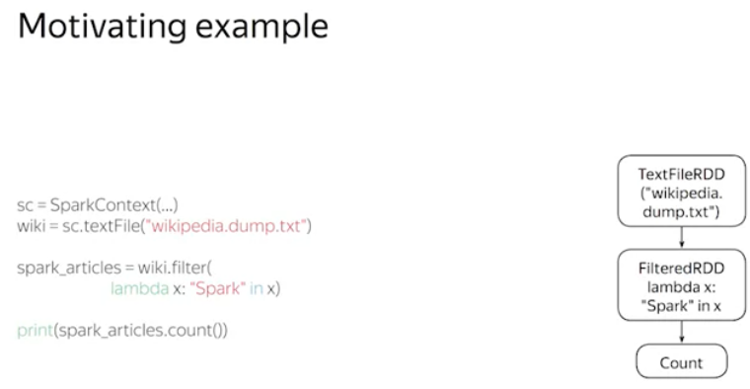

Now, imagine that you are working interactively with Spark, you have a shell with a Spark context, so you can create RDDS and invoke actions on them. Imagine you are willing to load a wikipedia dump from HDFS and see how many articles there contain the words Spark. You need to create the RDD, apply the filter transformation, and invoke the count action.

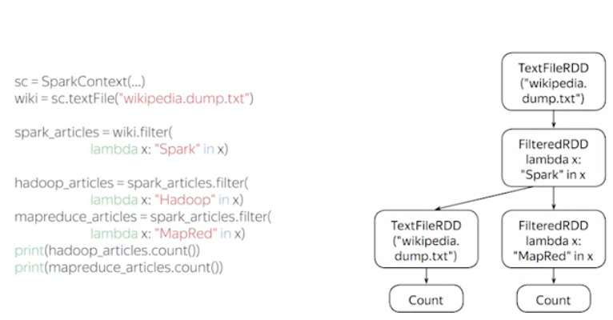

Now, among those articles with the Spark word, you would like to see how many of them contain the word, Hadoop and how many the word MapReduce. Well, that is exactly the same task you might say. And so the code will look like this, in the slide. While being semantically correct, this code might perform worse than you expect. The reason is that after completing the computation, Spark disposes intermediate data and those intermediate RDDs. That means, it will reload the Wikipedia dump two more times incurring extra input and output operations.

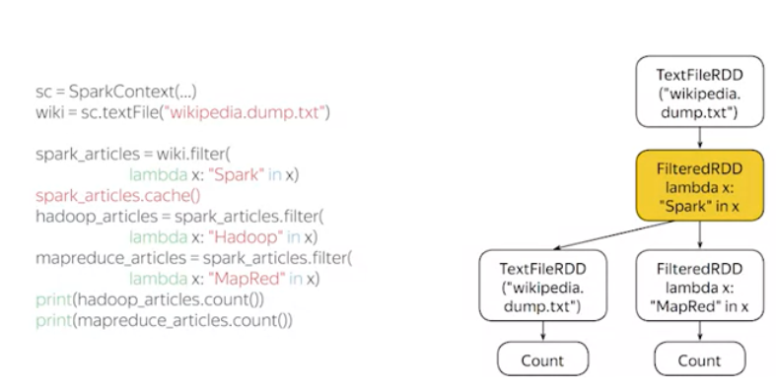

A better strategy would be to cache the preloaded dump in the memory and reuse it until you end your session. Spark allows you to hint which RDDs are better to be kept in memory or even on the disk. Spark does so by caching the blocks comprising your dataset. You can mark the data set as cached by invoking a cache method on it.

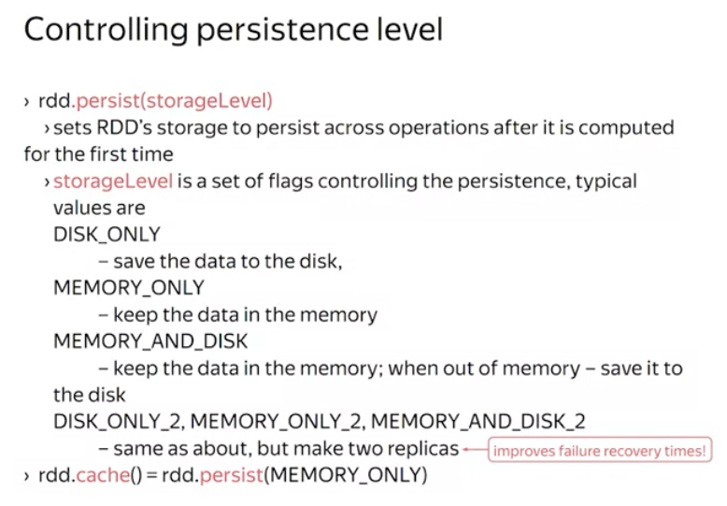

Actually, the cache method is just a shortcut for a more generic method called persist. This method allows you to set RDDs storage to persist across operations after the first time it is computed. This method is parameterized by a storage level. That is, a descriptor controlling the persistence behavior. Typical values for the storage level are disk only, which allows the data to be evicted to the disk. Memory only, which keeps the data in the memory and memory and disk, that tries to keep the data in the memory and evict it to the disk when running out of memory. The cache method is just a shortcut for the memory-only persistence. Also you may increase the replication factor to make more data replicas, thus reducing the impact of machine failures.

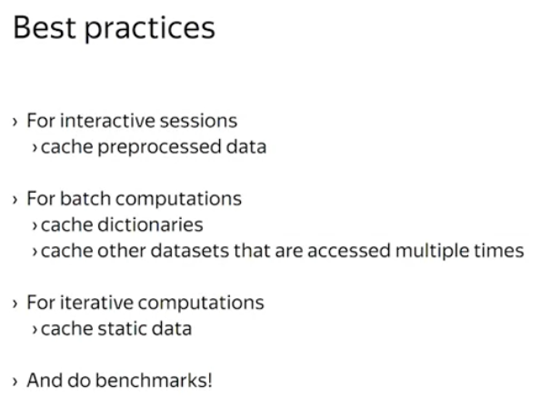

So, when and how should you tune the persistence level? The proof of the pudding is in the eating. So please benchmark your application to figure it out. However, here are a few rules of thumb that usually work.

* When running an interactive shell, it is a good idea to cache your dataset after you've done all the necessary preprocessing. That way, by keeping your work inside, in the memory, you would get a more responsive experience.
* When running a batch computation, it is a good idea to cache dictionaries that you join with your data. Join dictionaries are often reshuffled, so it would be helpful to speed up their read times.
* When running an iterative computation, again it is a good idea to cache static data like dictionaries or input datasets to avoid reloading the data from the ground up on every iteration. The static data tends to get evicted due to memory pressure from the intermediate data.

##### **Summary**

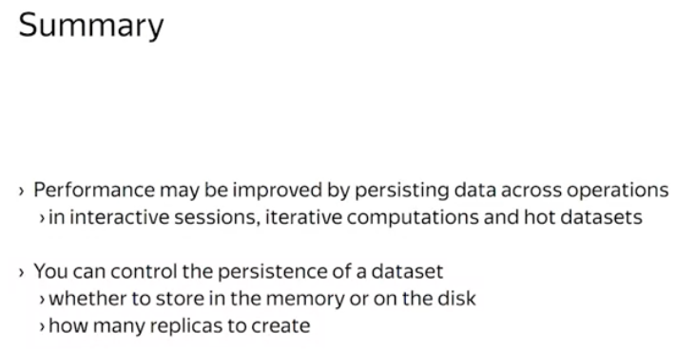

Sometimes application performance could be improved by persisting data across multiple operations. You can control the persistence of a dataset by choosing whether to store it on the disk or in the memory, and save the number of replicas. Best results are achieved by persistent, hot, reused static datasets in your application.

#### **4.2.3 Broadcast Variables**

Previously while learning Spark, we were concerned with parallelizing the computation by partitioning data and removing any communication between the tasks. All communication had happened by means of the shuffle.

Here you will learn about the restricted forms of the shared memory available in Spark. Usually, in concurrent programming, a shared memory is a powerful abstraction, but often misused.

It can make the developer's life easier and at the same time it can make the application performance deteriorate because of extra synchronization.

This is why in spark there are restricted forms of the shared memory. There is no way to abuse them to lose concurrency.

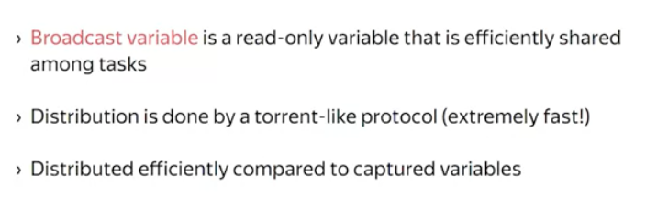

Here you will learn about broadcast variables. They are, in essence, shared randomly variables that are distributed efficiently among tasks.

You may argue that you can share a variable among the task by including it into the closure.

So what is the difference?

The difference is in the distribution product.

When it captures a variable into the closure, it is sent to an executor together with a task specification.

That is, one to many communication.

When you create a broadcast variable, it's content is distributed in a torrent-like version.

Torrents can make your networks clicks burn. And this is because they implement many to many communication protocols.

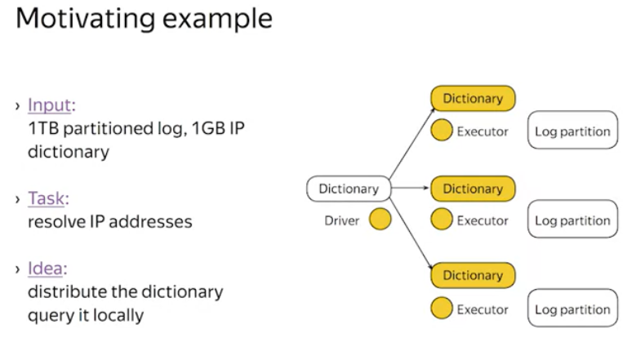

Okay, you may wonder, why do we need such a fast distribution mechanism where we can use it?

Let me give you a motivating example.

Imagine you are working with 1 terabyte access log for your website.

And you would like to resolve IP addresses to countries, to get a better understanding of your visitors. This resolution is usually performed with an aid of a special database that maps IP addresses to geographical units. Less accurate versions of this database occupy about half a gigabyte of disc space, while the most accurate one occupy up to several gigabytes. Let's assume the size of 1 gigabyte for simplicity.

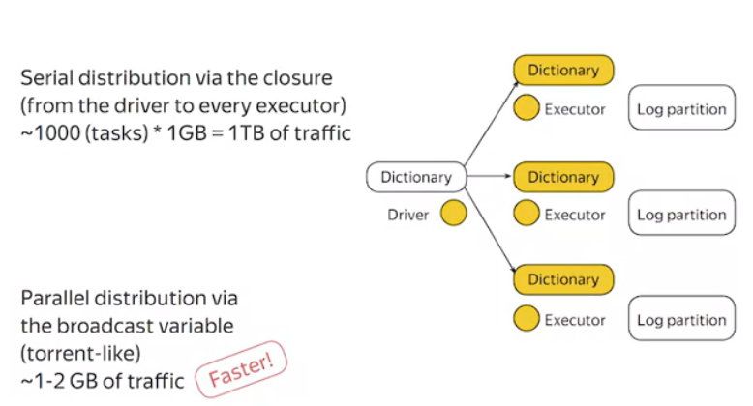

One way to implement your application would be to put the database into the RDD and make it join with the log.

However, it will require shuffling 1 terabyte of data.

A better way would be to maybe so-called map-side join. That is to distribute the database to every mapper and query it locally.

Now, if you are about to start 1,000 map tasks, and you are distributing the database via the closure, that would create 100 times 1 gigabyte of outgoing traffic which is 1 terabyte at the driver load. That is a lot.Distributing the database via a broadcast variable, we take slightly more than 1 gigabyte of outgoing traffic at the driver node. Maybe up to 2 gigabytes. That's 500 times to 1,000 times faster. Of course, you can replace the database in the example with the machine they remodel and the argument would still hold.

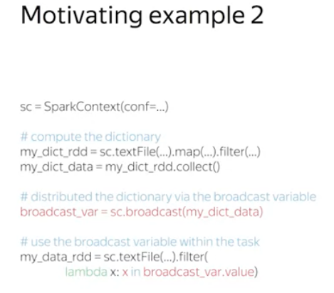

Let me show you another trick that might be helpful.

Newcomers to the field sometimes think that they have to put their entire computation into a single transformation graph with one action at the end.

Well, this is not true, in fact, here is what you can do with Spark. You can setup a transformation graph to compute a dictionary,

invoke the collect action to into the driver's memory and then put it into the broadcast variable to use in further computations.

The idea is to off-load computations to spark executors and use the driver program as the coordinator.

##### **Summary**

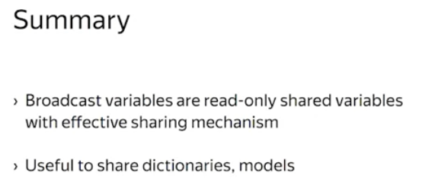

Now, that concludes the lesson on broadcast variables. The takeaway is that broadcast variables are read-only shared variables with effective sharing mechanism.

You can use them to share large dictionaries or models and the only limit is the memory. Variables must fit there.

#### **4.2.4 Accumulator Variables**

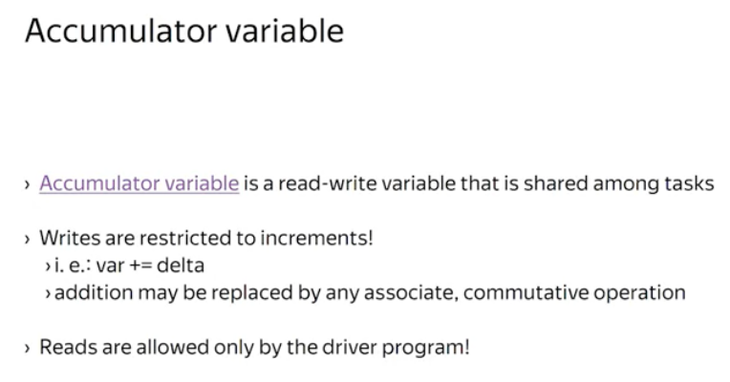

Accumulators are shared read-write variables, but the only way you can update them is by adding a delta. The addition here may be replaced by any commutative and associative user defined operation. Restricting the write operations allows the framework to avoid complex synchronization thus making the accumulators efficient.

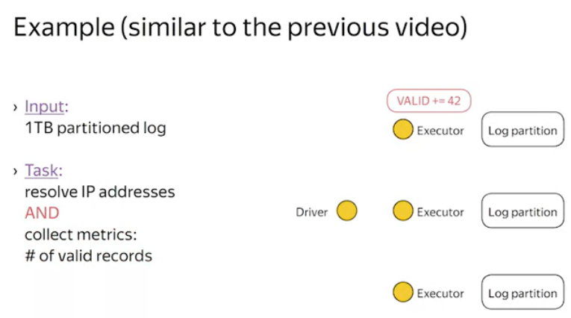

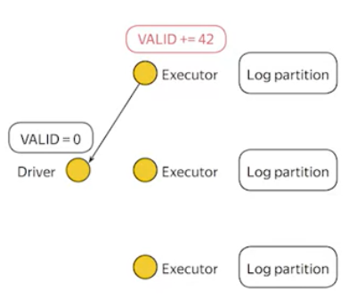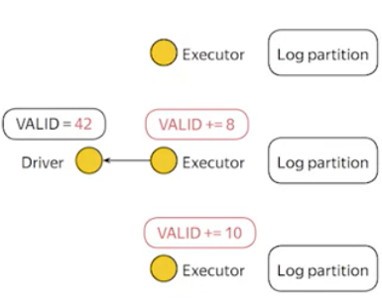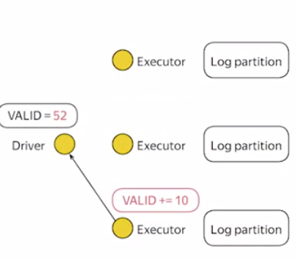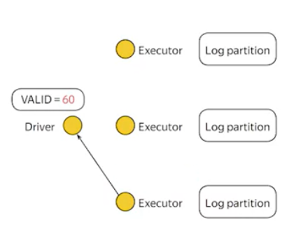

Another important restriction is that the accumulator variable could be read only by the driver program and not by the executors. Thus, you cannot read the accumulated value from within a task. This restriction is due to the implementation of the accumulators. Let's see how they work. When the accumulator gets incremented on the particular executor, the delta is sent back to the driver program together with a task outcome. Therefore, there is just one natural aggregation point where we can compute the total value, that is the driver.

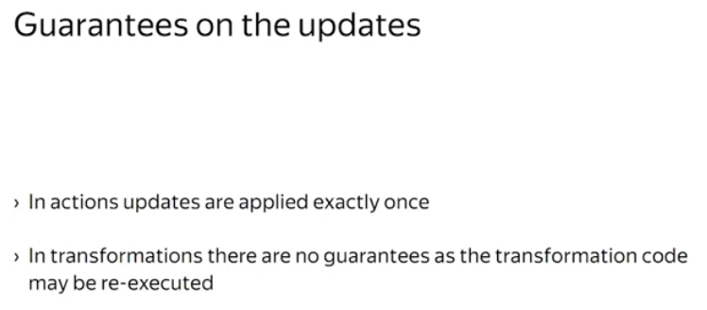

It is also important to note that updates generated in actions are guaranteed to be applied only once to the accumulator. This is because successful actions are never re-executed and Spark can conditionally apply the update. For updates in transformation, there are no guarantees when they accumulate updates. Transformations can be recomputed on a failure on the memory pressure or in another unspecified codes like a preemption. Spark provides no guarantees on how many times transformation code maybe re-executed.

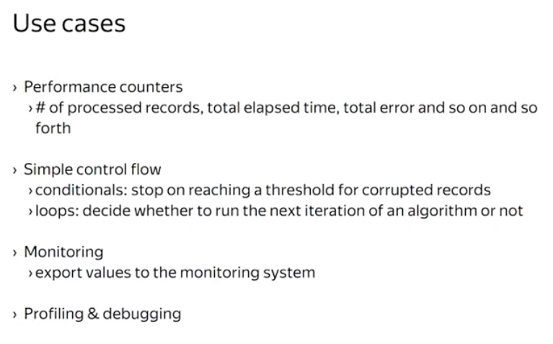

Wondering why would you need an accumulator? The most obvious usage is for performance counters. You may want to count the number of corrupted or invalid records or you may want to compute accumulative error in your machine in an application. For example, to decide whether to run the next iteration of an algorithm or not. Or you may want to keep track of cumulative elapsed time. Keep in mind that accumulators are intended to be used sparingly. That is it is not advisable for example to compute the number of visitors per country and to compute user id blue filters within the accumulators framework. First and foremost, accumulators are for debugging, monitoring and profiling.

##### **Summary**

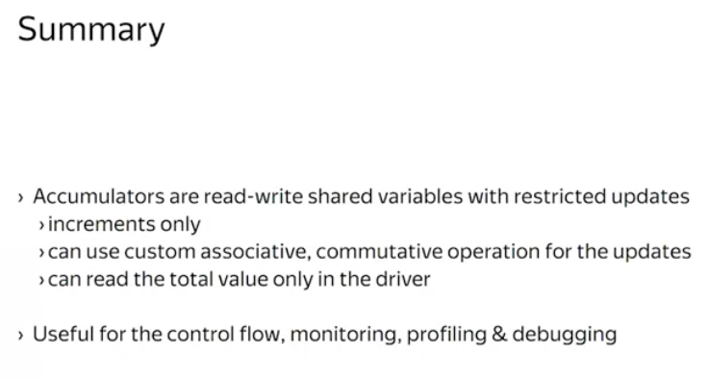

To summarize, accumulators are shared read-write variables with de-coupled read and write sides. Accumulators could be updated from actions and transformations by using an increment. Reads could be done only by the driver program. You may implement a custom associative and commutative operator for an accumulator. Many use cases include debugging, monitoring and profiling. This video concludes the second lesson on Spark. We have covered advanced topics such as execution, scheduling, caching, persistence and shared variables.

### **4.3 Working with Spark in Python**